Title of the Paper

First-name and surname of the author and co-author(s)
(without academic titles)

Abstract
There shall be an English abstract ranging between 200 - 250 words. Please explain here the aim of the paper, the methodology and main results.
Keywords: word, word, word (4-6 keywords)
- introduction
- theoretical background / LITERATURE REVIEW
- methodology
- results
- DISCUSSION
- conclusion
The actual text of the paper should be divided into chapters where possible. Headings can be maximum in two levels and numbered (e.g. 1 TITLE OF CHAPTER, 1.1 Title of sub-chapter).
  - Title of sub-chapter
Tables and figures should be numbered and pertaining references must be included in the text. The acceptable labeling for a table is Tab.1 and Fig. 1 for a figure. The title of the table or figure and the source should follow. The text should be composed in such a manner that there are not too many figures or tables on a single page. Tables and figures in a landscape format are not acceptable.
Tab. 1 – The title of the table. Source: own research
10 pt. Times New Roman
Figures and tables should be supplied in a sufficient quality for print. They can be supplied as separate documents (jpg, xls or doc). The quality of the above is the responsibility of the author.

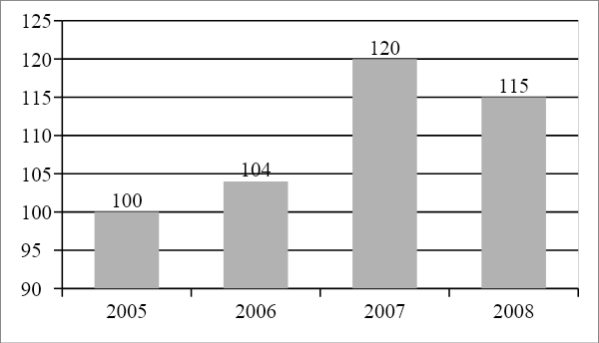
Fig. 1 – The title of the figure. Source: own research
Equations and formulas are denoted by numbers in round parentheses and it is recommended that they are produced by Editor of equations or inserted in a jpg format.
 | 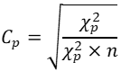 | (1)
In-text citations and the Reference list should follow the referencing style used by the American Psychological Association (APA style). Details concerning this referencing style can be found at https://libguides.murdoch.edu.au/APA
Notes under the line are not acceptable.

Acknowledgement
The authors would like to thank … for providing financial support.

References
Audretsch, D. B., & Feldman, M. (1996). Innovative Clusters and the Industry Life Cycle. Review of Industrial Organization, 11(2), 253-273. doi: 10.1007/BF00157670
Badiru, A. B. (2014). Handbook of industrial and systems engineering. Boca Raton: CRC Press.
Chiculita, C., & Frangu, L. (2015). A Low-Cost Car Vibration Acquisition System. In 2015 IEEE 21st International Symposium for Design and Technology in Electronic Packaging. Brasov, Romania: IEEE. doi: 10.1109/SIITME.2015.7342341
Corbett, L. M. (2011). Lean six sigma: The contribution to business excellence. Lean Six Sigma Journal, 2(2), 118-131. doi: 10.1108/20401461111135019
Dlabac, J. (2014). Stihly materialovy a hodnotovy tok. MM Prumyslove spektrum. Retrieved from https://goo.gl/14Wn3G
Goller, N., & Bronnsack, T. (2019). Gemeinsam stark. Georg Thieme Verlag. Retrieved from https://www.thieme-connect.com/products/ejournals/html/10.1055/a-0854-8785
ISO 8606:1995. Mechanical Vibration –Road Surface Profiles –Reporting of Measured Data. ISO -International Organization for Standardization.
Joneson, E. (2014). ASTM D10.21 D4169 Revision –random vibration update. ISTA TransPack International Forum.
Matt, D. T., Krause, D., & Rauch, R. (2013). Adaptation of the value stream optimization approach to collaborative company networks in the construction industry. Paper presented at the 8th CIRP International Conference on Intelligent Computation in Manufacturing Engineering, Ischia, Italy. doi: 10.1016/j.procir.2013.09.069
Sellers, B. (2014). Value stream mapping in healthcare. In J. A. Larson (Ed.), Management engineering: A guide to best practices for industrial engineering in health care (pp. 225-230). Boca Raton: CRC Press.
Sharma, S. (2002). Research in Corporate Sustainability: What Really Matters? In S. Sharma & M. Starik (Eds.), Research in Corporate Sustainability: The Evolving Theory and Practice of Organizations in the Natural Environment. Cheltenham, UK: Edward Elgar.
Statista. (2019a). Entwicklung der verkauften Auflage der Tageszeitungen in Deutschland in ausgewählten Jahren von 1991 bis 2019. Retrieved from https://de.statista.com/statistik/daten/studie/72084/umfrage/verkaufte-auflage-von-tageszeitungen-in-deutschland/
Thurston, J., & Ulmer, J. M. (2016). The principles of lean manufacturing. Franklin Business & Law Journal, 2016(2), 57-70. Retrieved from https://goo.gl/cT992C
…more examples at https://libguides.murdoch.edu.au/APA

References should be arranged first alphabetically and then further sorted chronologically if necessary. More than one reference from the same author(s) in the same year must be identified by the letters "a", "b", "c", etc., placed after the year of publication.

Contact information

Name Surname (with titles)
Organisation / University, Faculty
Address of organisation / university, faculty
E-mail:
Phone number:
ORCID:

Name Surname (with titles)
Organisation / University, Faculty
Address of organisation / university, faculty
E-mail:
Phone number:
ORCID:

Name Surname (with titles)
Organisation / University, Faculty
Address of organisation / university, faculty
E-mail:
Phone number:
ORCID:
ORCID identifier is important for post processing of your paper, especially for indexing in WoS. If you do not have an ORCID, please create it. https://orcid.org

